STEP 1: Digitize your image by scanning

Scan in your image at the highest resolution possible. This might say something like “1200 dpi”, “best” or “photo”. The smaller your starting image, the more important it will be to choose a high resolution since this will allow you to enlarge your image once printed. ‘Resolution’ refers to the number of pixels that make up your image. You want to make sure you have at least 150 of them for every inch you want your final print to be, so it’s a good idea to capture as many as you can in that first scan by using a high quality setting.

STEP 2: Crop your image
Your image can be any aspect ratio or shape you want, but for this example we’re going to make a perfect square. You should have the option with your scanning software to crop the image once it’s scanned into your computer. If you do not see that option, most basic image-editing software should have a crop tool.

STEP 3: Upload your digital file
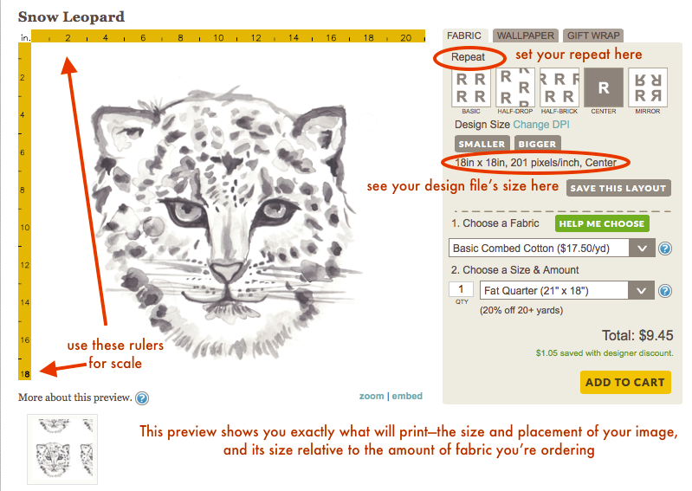
Once you log into your Spoonflower account, click on "Create" in the navigation, then select the type of product you are creating (fabric). This will take you to the image upload page for that substrate. Confirm the copyright, then upload your file. It will now live in your design library permanently.

OPTIONS:
Choose a Repeat
If you don’t want a single large image, the repeat layouts built into our site give you several options for filling the fabric with your design. When you first upload your image to Spoonflower, our “Basic Repeat” will be selected as the default, but you may want to choose another option.

Use the Color Changer Tool

Our Color Changer and PicMonkey features are unavailable for images larger than a fat quarter, or 21" x 18" at 150 dpi. To change or reduce the number of colors in your design navigate to the design order page for the design you would like to edit and click Change Colors.

Make it Marketplace Ready
1. Pick a descriptive name. Be sure to create a unique and fun name for your design!
2. The description should be information about your design. What media you used, etc.
3. You can also add more to the description on the Additional Details section.
4. The thumbnail will be the small image that customers will be able to see initially of your design before clicking on it to be wowed by your creation. Make sure you select the best of the three images that you see there.
ORDERING
Before adding the fabric to your cart, be sure that the image looks exactly perfect in the large preview against the yellow rulers, as this is an accurate depiction of how the fabric will print.

- choose a fabric
- choose an amount
- add it to your cart

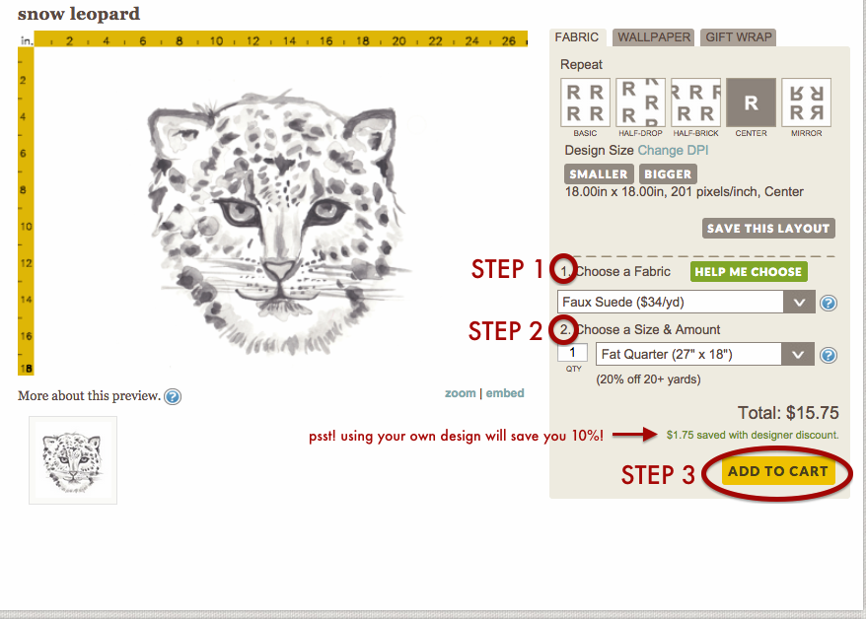

CHECKING OUT: in the cart you will choose your shipping method, apply Spoondollars, and enter a promo code if you have one!

Here you can also choose to hide prices and add a message if it’s a gift. We will email with confirmation of your order, and send you another email with a tracking number when your order ships. Standard orders ship USPS, and all expedited orders ship out via Fedex. You did it! Use your Spoonflower fabric for something awesome.

